Q1.
Answer is B.

A: can work.
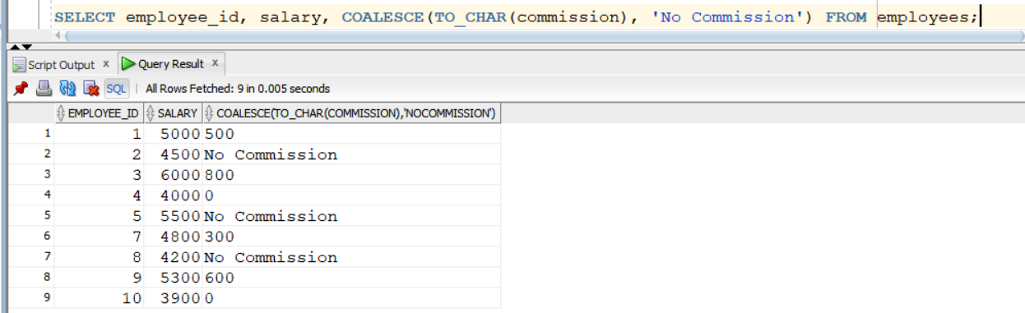

B: is valid and correct.
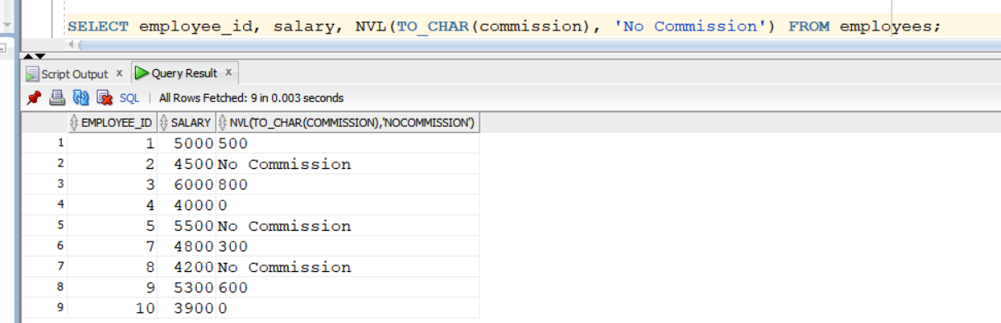

C: It does not replace NULL with a value, it only converts a specific value to NULL.
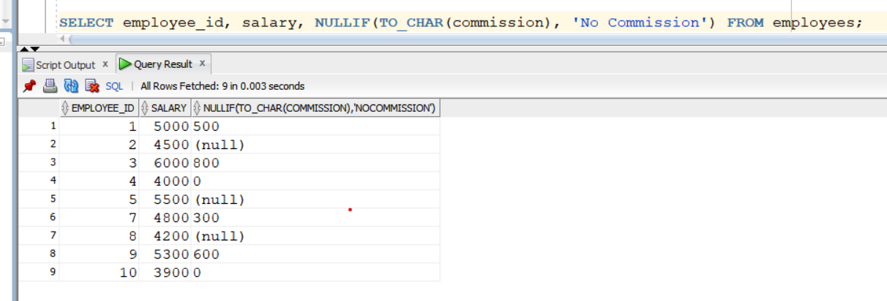

D: It is also work but B is simplest one.
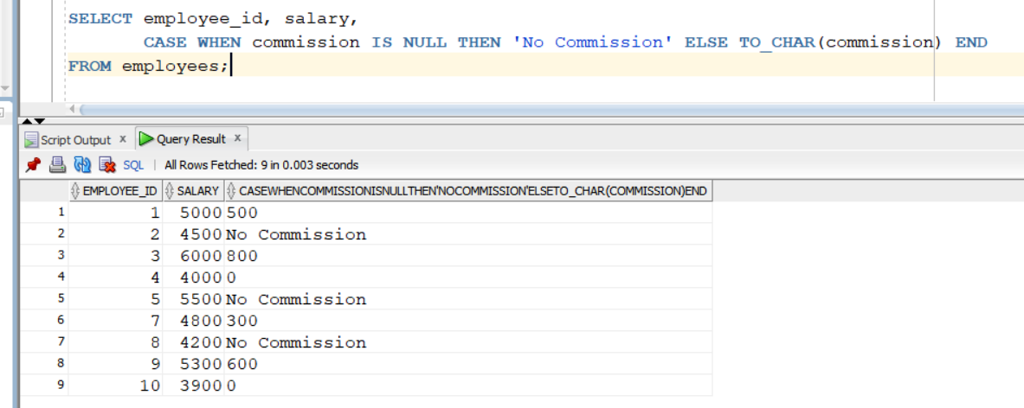

Q2.
Answer is C.

A:Only replaces NULL, not equal values
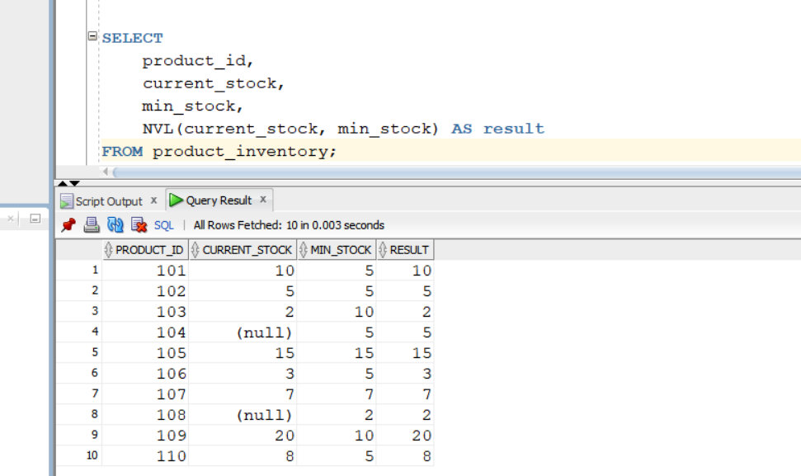

B: Only handles NULLs, not equality.
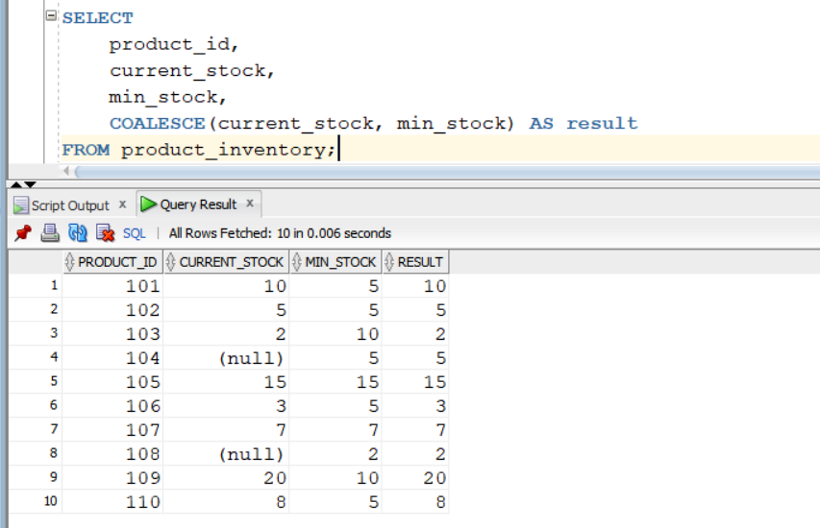

C: Returns NULL if both values are equal.
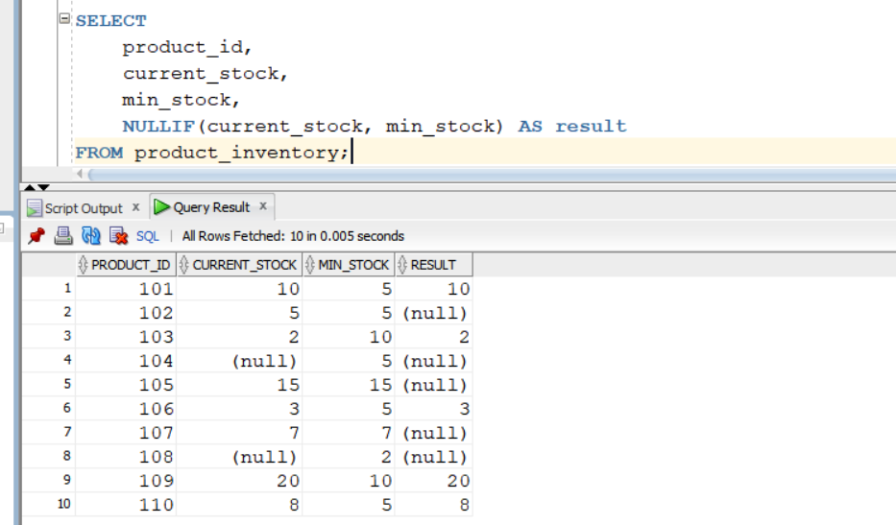

D: Does exactly what NULLIF does but with explicit logic.
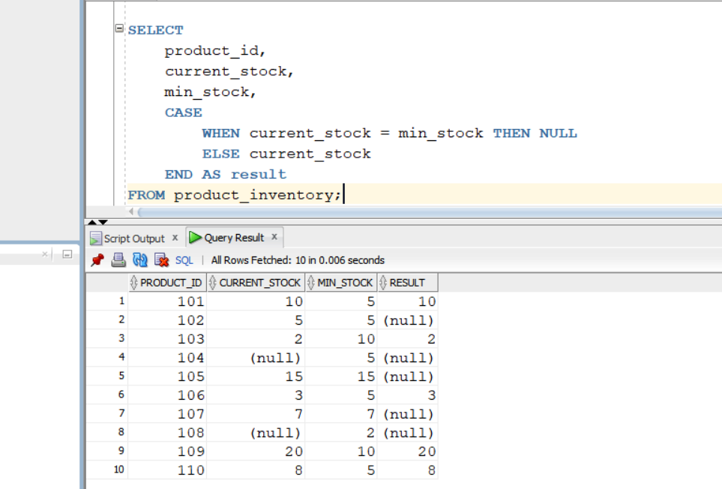

Q3.
Answer is B.

A: It works sometimes, but not safe or best practice.
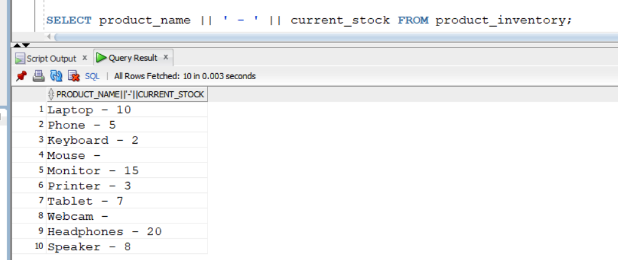

B: Correct Answer.
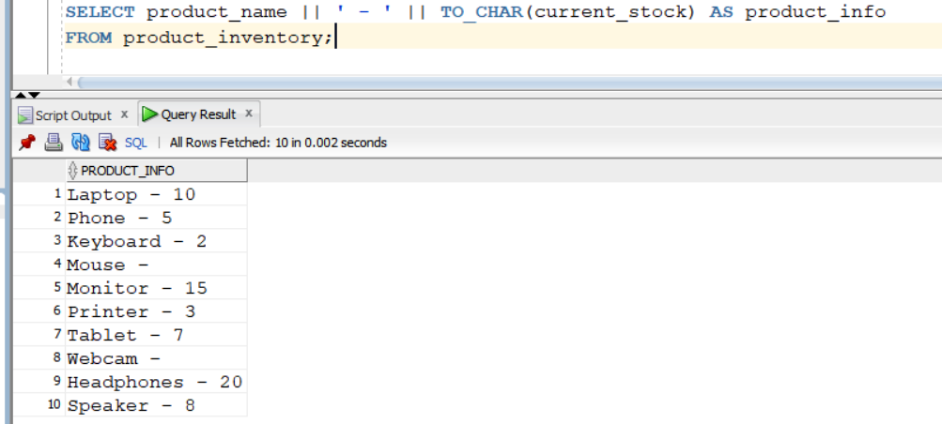

C: TO_NUMBER is used for converting strings that contain digits only.
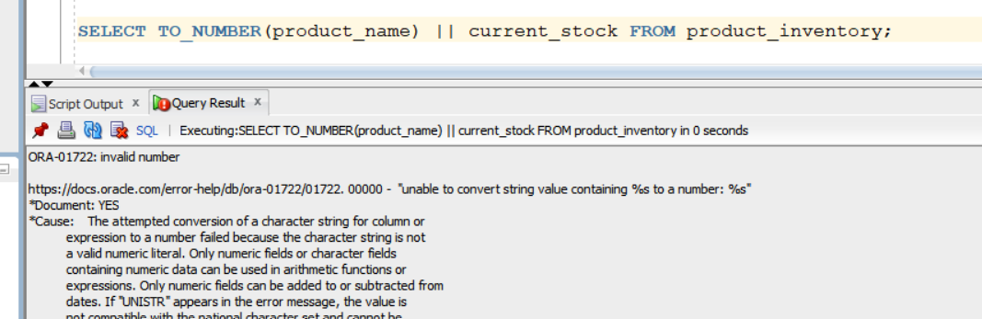

D: Work but overkill.
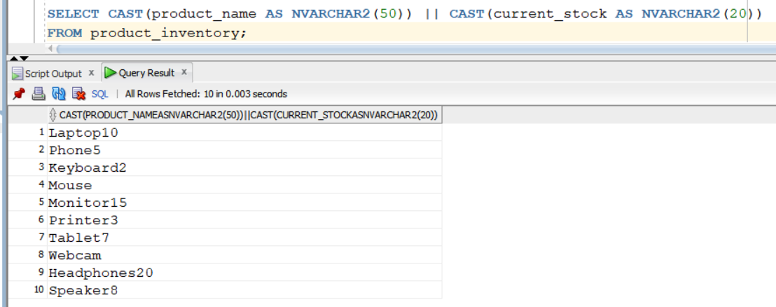

Q4.
Answer is B.

A: It only works when the column is NULL, not when it contains text like 'N/A'.
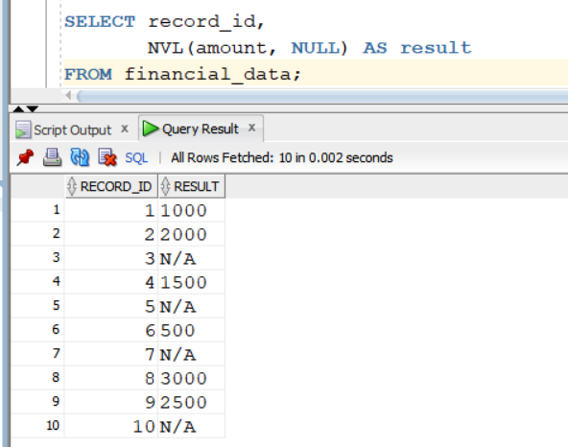

B: Works perfectly for treating 'N/A' as NULL.
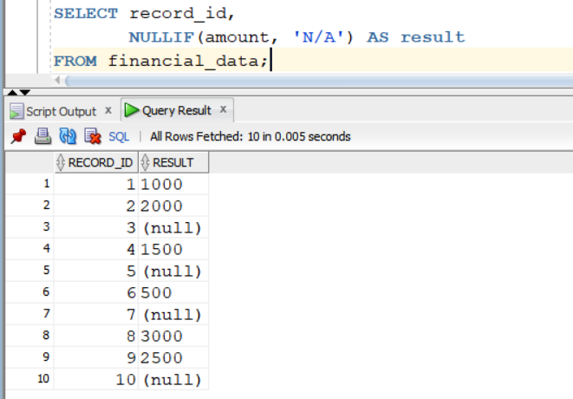

C: No effect — same as column.
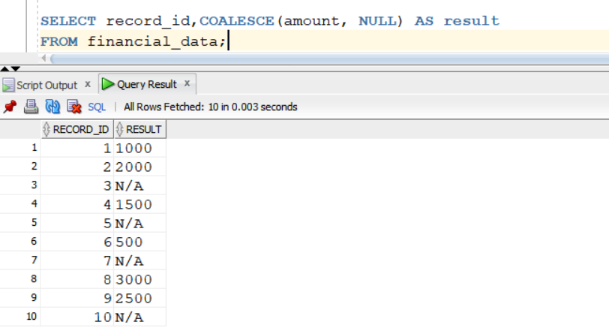

D: Same as NULLIF() — converts 'N/A' → NULL.Works correctly, but longer syntax.
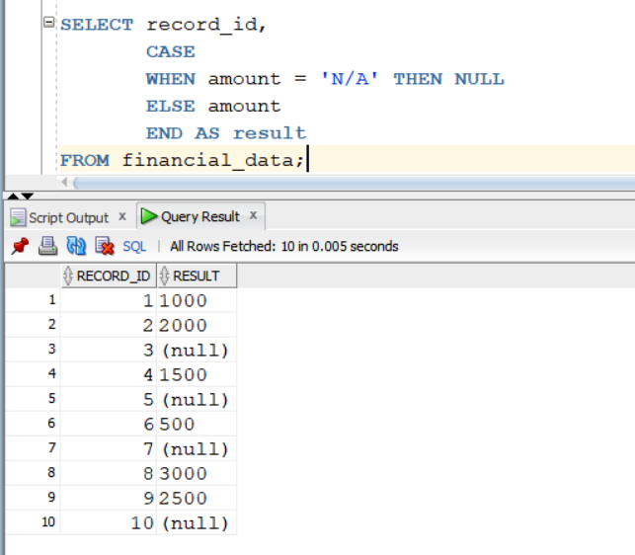

Q5.
Answer is A.

A: Returns rows where the converted string date matches the date_column value.
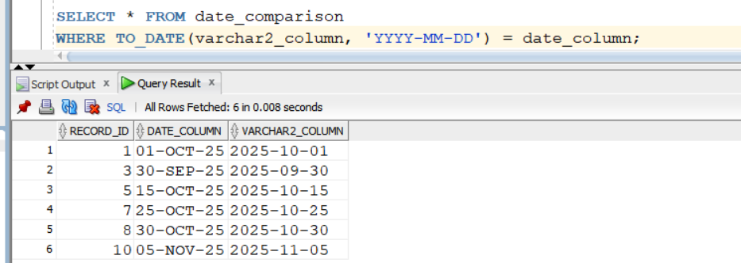

B: Work but less efficient.
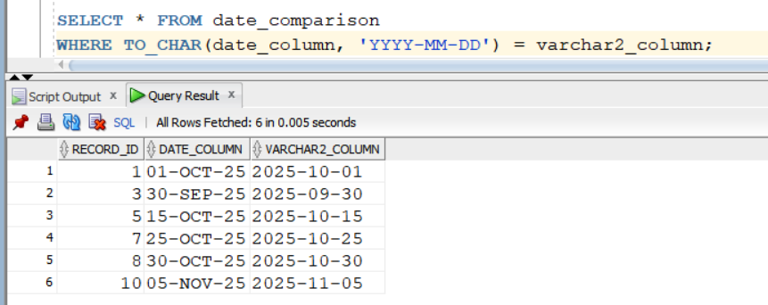

C: Not recommended because it depends on NLS settings, which vary by session.
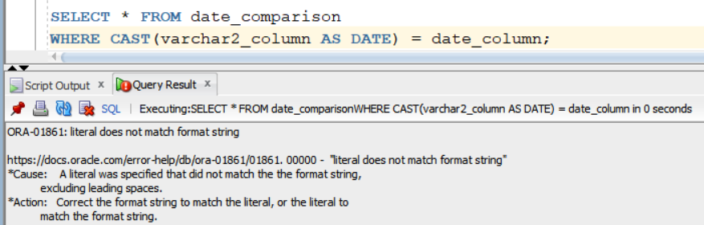

D: Also very inefficient — Oracle has to do conversions row by row.
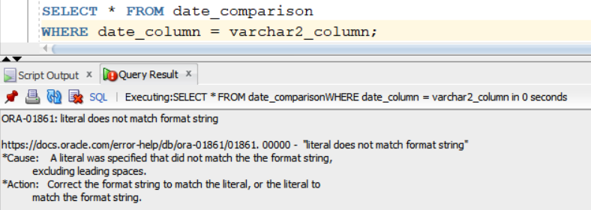

Q6.
Answer is A.

A:

